METHODS OF SELECTION OF EMPIRICAL FORMULAS
General information
In the process of experimental measurements, a statistical series of measurements of two quantities are obtained, which are combined by the function y = / (x), here each value of the function y y2, ..., up corresponds to a certain value of the argument x x2, ... , xp.
Based on experimental data, it is possible to select algebraic expressions, which are called empirical formulas. Such formulas are selected only within the measured values of the argument. Empirical formulas are of greater value the more they correspond to the results of the experiment. The selection of empirical formulas is necessary in cases where the analytical expression is complex, requires cumbersome calculations, computer programming, etc. Experience shows that empirical formulas are often indispensable for the analysis of measured quantities. There are two main requirements for empirical formulas:
* 1) if possible, they should be the simplest;
* 2) exactly match the experimental data within the limits of the argument change.
Therefore, empirical formulas are approximate expressions of analytical formulas. Replacing exact analytical expressions with approximate, simpler ones is called approximation, and functions are approximating.
The process of selecting empirical formulas consists of two stages
• * 1) The measurement data is applied to the coordinate grid, the points of the smooth curve are connected and the formula type is chosen approximately.
• 2) Calculate the parameters of formulas (coefficients) that would best correspond to the accepted formula. The selection of empirical formulas should begin with the simplest expressions.
The measurement results of many phenomena and processes are approximated by the simplest empirical equations of the type (or linear equation) where a and b are constant coefficients.
Alignment method
When analyzing graphic material, it is necessary to use a linear function whenever possible. In this case, the alignment method is used. It consists in the fact that the curve constructed from experimental points is represented by a linear function.

In this case, x and y should be connected by a linear relationship
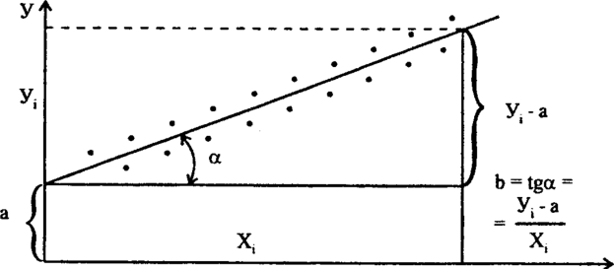
Fig. 6.27 Graph of the form y = a + Bx'

The values of x and y can be calculated based on the solution of the system. Next, a straight line is constructed (Fig. 6.12), along which it is easy to graphically calculate the parameters a (ordinate of the intersection point of the straight line with the y axis) and b (tangent of the angle of inclination of the straight line with the x axis).
When graphically determining the parameters a and b, it is mandatory that the straight line be plotted on a coordinate grid whose origin is the point y = 0 and x = 0. To calculate the coefficient b, it is necessary to take the points y and x on the extreme sections of the straight line.
The method of extreme points
Another graphical method can also be used to determine the parameters of a straight line. The coordinates of the two extreme points taken from the graph are substituted into equation (6.21). A system of two equations is obtained, from which a and B are calculated. After setting the parameters a and b, an empirical formula (6.19) is obtained, which connects y and x, which makes it possible to establish a functional relationship between x and y and an empirical dependence y = / (x).
The linearization of curves can be easily carried out on semi- or logarithmic coordinate grids, which are widely used in the graphical method of selecting empirical formulas..

Example. Choose an empirical formula for the following measurements
Ло | У | 12,1 | 19,2 | 25,9 | 33,2 | 40,5 | 46,4 | 54,0
А1 | X | 1 | 2 | 3 | 4 | 5 | 6 | 7
Graphical analysis of these measurements shows that in rectangular coordinates the points fit well on a straight line and they can be expressed as a dependency
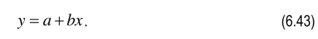
Select the coordinates of the extreme points and substitute in

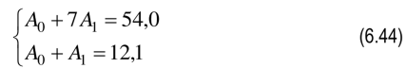
the equation from where
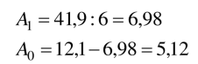
The empirical formula has the form
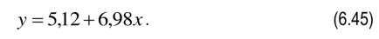
Thus, the approximation of experimental data by rectilinear functions allows you to easily and quickly establish the type of empirical formulas.
Basic cases for data approximation
The graphical alignment method can be applied in various cases when the experimental curve on a grid of rectangular coordinates has the form of a smooth curve. Let's consider the main cases.
1 If the experimental graph has the form (Fig. 6.13, a), then it is necessary to apply the formula

Replacing x = lg x and y = lg y, we have y = lg a + Bx.
In this case, the experimental curve turns into a straight line on a logarithmic grid.
2 If the graph has the form (Fig. 6.13, b), then you need to use the expression
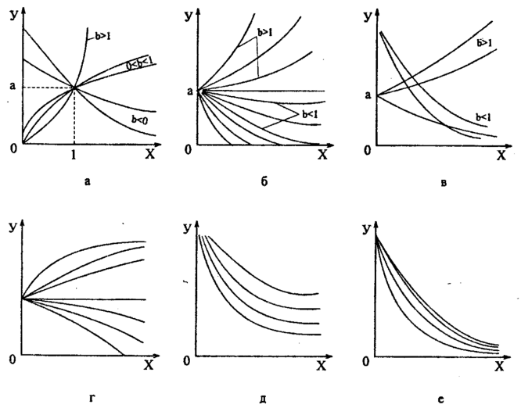
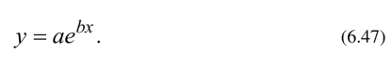
Replacing y = lg y, we have y = g a + xb Igex. Here the experimental curve turns into a straight line on a semi-logarithmic grid.
3 If the graph has the form (Fig. 6.13, c), then we apply

a) Let b be given, then, taking x = x, we have a straight line on the grid of rectangular coordinates, i.e.
Fig. 6.28 The main types of graphs for the selection of empirical formulas:
a - power-law y - ah b - exponential y = abx; c - y = ah + c functions; d- y = ae x+ c functions;
d - fractional-linear y = a + b/c; e - y = -
a + Bx
b) Let b be unknown. Taking x = n x and y = n (y - c) we have a straight line on the logarithmic grid

In this case, it is necessary to pre-calculate with . To do this, three arbitrary points are taken along the experimental curve: x y x2, y2>
X3 = l1XXx2 ’ Uz and calculate with

4 If the experimental graph has the form (Fig. 26, d), then you need to use the formula

Replacing y = lg (y - c), we have a straight line on a semi-logarithmic grid

It is necessary to pre-define c, using (6.27), but given that

5 If the graph has the form (Fig. 6.13, E), then we apply the expression

n 1
Replacing x = —, we get a straight line on the grid of rectangular coordinates
Z

6 If the graph has the form (Fig. 6.13, e), then we need to use the formula

Replacing y = —, we have z = a + Bx, i.e. a straight line on a grid of rectangular
Z
coordinates.
With the help of the above graphs and expressions, it is almost always possible to find an equation of an empirical formula.
Example. Choose an empirical formula for the following measurements:
У | 1 | 1,5 | 2 | 2,5 | 3,0 | 3,5 | 4,0 | 4,5
X | - 1  - 5,2 | - 2  - 0,6 | - 2  - 7,4 | - 3  - 6,7 | - 4  - 9,2 | - 6  - 6,0 | 00  |> | - 117,  - 5
Based on these data, we construct a graph, we have a typical exponential
function y = dv (Fig. 6.14), in this formula it is necessary to find a and B.
After the logarithm of this expression, we have lg y = lg a + bgex. Denote lg y = y, then y = lg a + b lg ex, i.e. in semi-logarithmic coordinates y represents a straight line.
Substitute the coordinates of the extreme points into the equation or
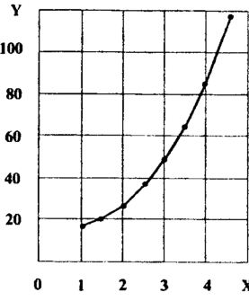

Fig. 6.29 Graph of the function y = a e
Bx
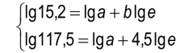
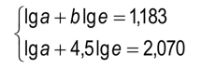
Subtracting the first from the second expression, we get

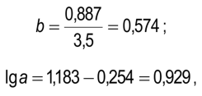 hence a = 1.85.
Finally , the empirical formula has the form

